Student Name : Pyae Phyo Aung
Student ID : 0726017003
Assignment Number : III
Docker hub link : https://hub.docker.com/repository/docker/learncloudhub/calc-app/general

Task 1: Create the Python Application
- Version 1 – Local Test and Docker Test Screenshot showing the Python program running locally with two input numbers and the addition result. Screenshot showing docker images with calc-app:v1. o Screenshot showing calc-app:v1 running successfully in interactive mode and displaying the addition result.

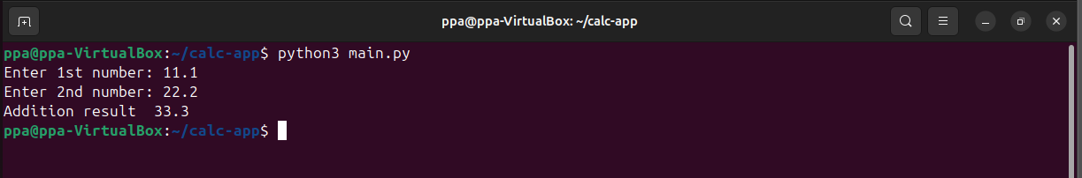

Task 2: Create Docker Image Version 1
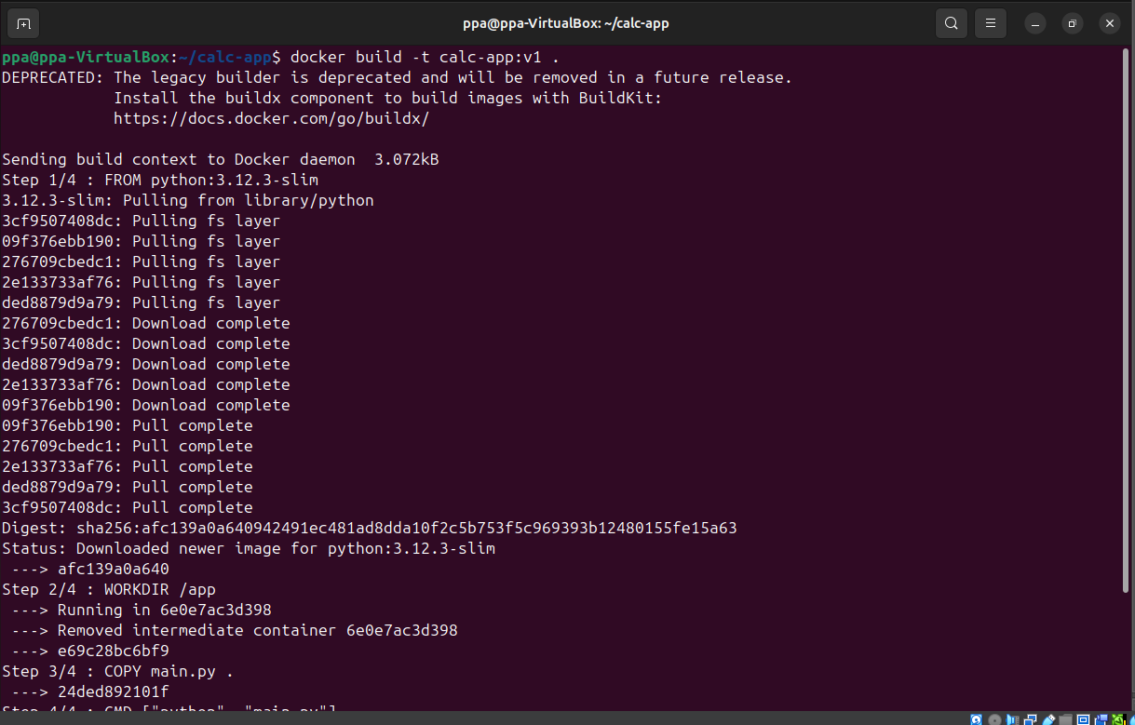
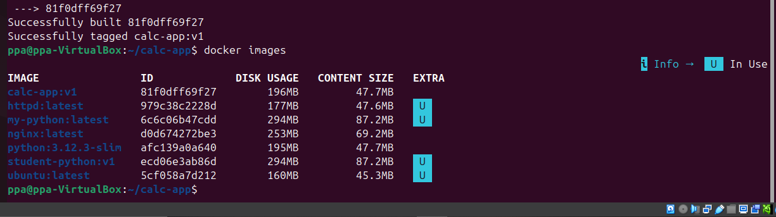
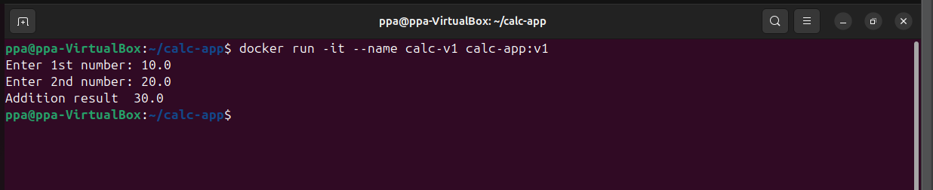

Task 3: Push Version 1 to Docker Hub
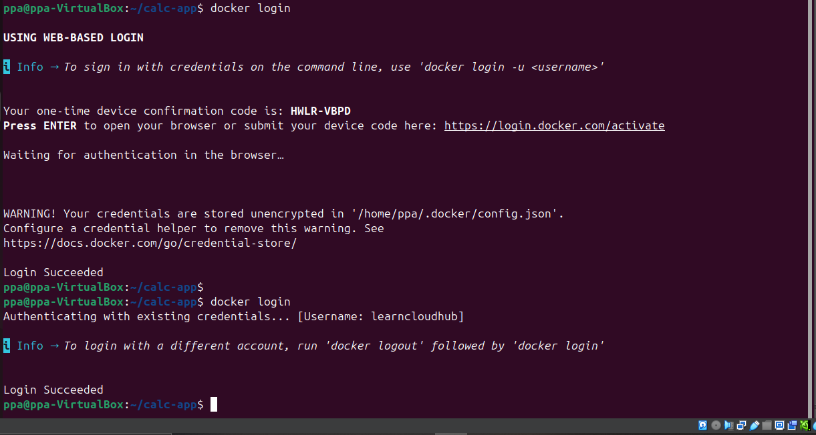

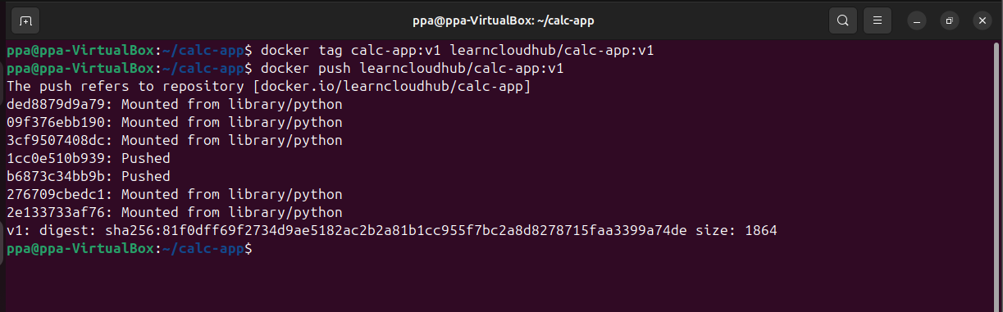

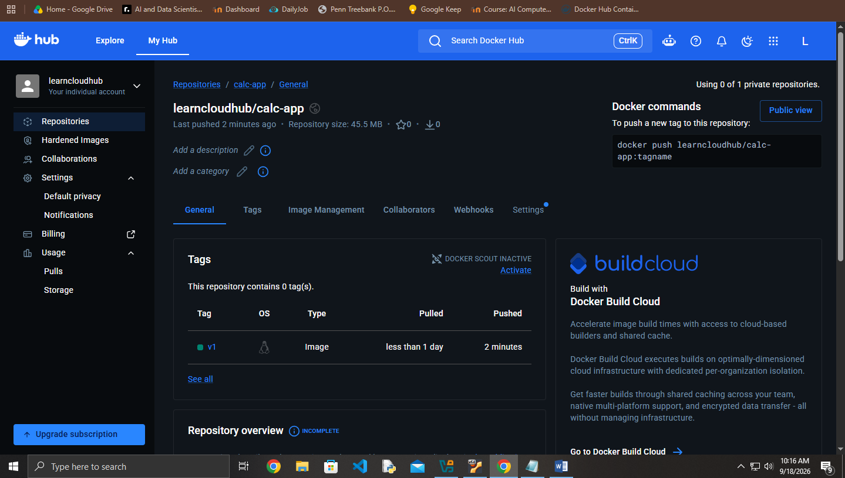

Task 4: Modify the Application
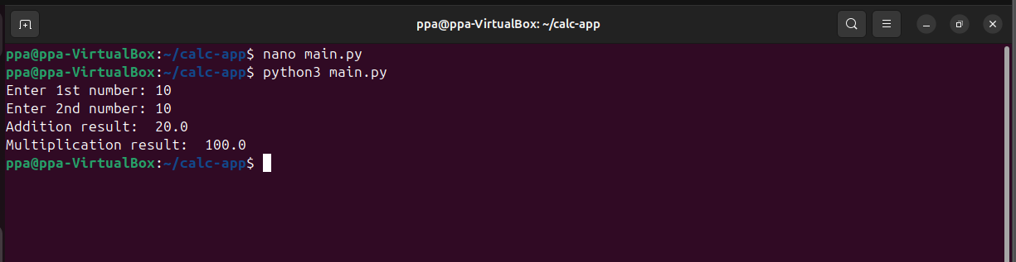

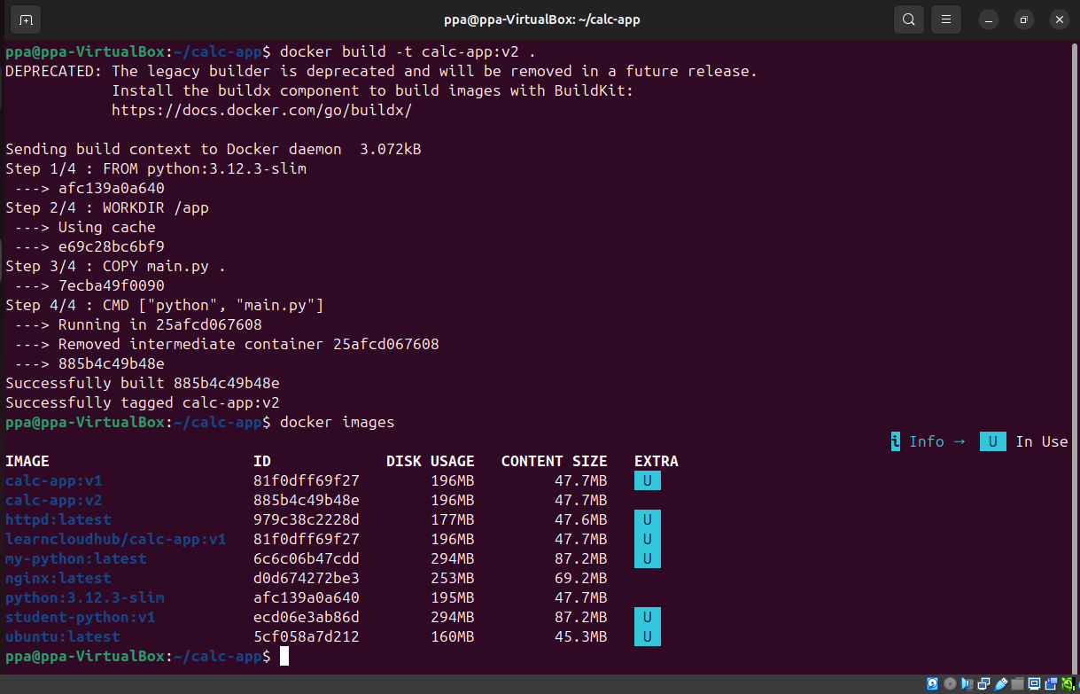

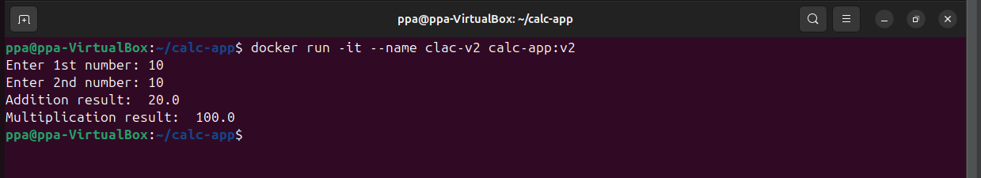

Task 6: Push Version 2 to Docker Hub
